Grade 7 Accelerated · Unit 3 · Lesson 3  Exponential Expressions  Question Bank 3.03 ANSWER KEY | Name  Date  Period

Show your work. Circle your final answer.
1. Two students evaluated 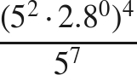. Patricia first wrote 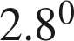 as 1, then 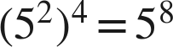, then 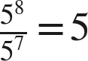. Kim first wrote 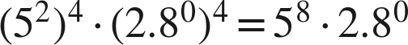, then 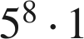, then .
a. Name the law Patricia used first, and the law she used second.
zero exponent, then power of a power
b. Name the law Kim used first.
power of a product (the exponent 4 went to both factors)
c. Name the law both students used last, and give the value of the expression.
quotient of powers; the value is 5

For questions 2 through 5, use the laws of exponents to evaluate. Show each law you use.
2. 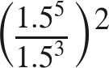
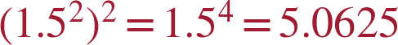

3. 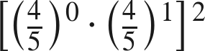
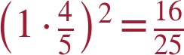

4. 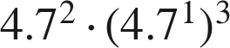

5. 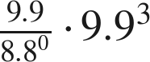
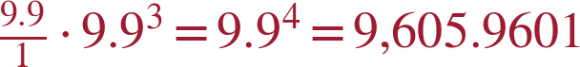

For questions 6 and 7, evaluate. Show each step.
6. 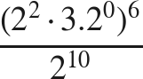
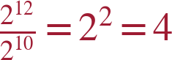

7. 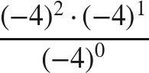
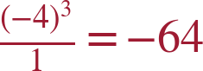

Equivalent or not.
8. Select ALL of the expressions that are equivalent to 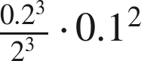.
☒ A. 
☒ B. 
☐ C. 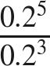
☒ D. 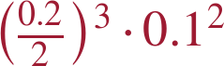
☐ E. 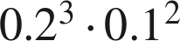
☐ F. 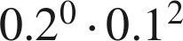
A, B and D
The expression is 0.1³ · 0.1² = 0.1⁵ = 0.00001.

9. Which expression is equivalent to 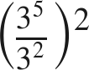 ?
○ A. 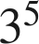
● B. 
○ C. 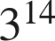
○ D. 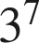
B
3³ squared is 3⁶ = 729.

Working backwards.
10. Find the value of that makes each statement true.
a. 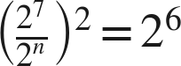
n = 4
Inside must be 2³.
b. 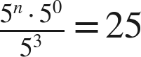
n = 5
5^{n-3} = 5².

11. Ruth says that 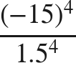 can be rewritten as 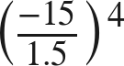 before evaluating. Is she right? Name the law, and give the value.
Yes — power of a quotient, read from right to left; .

